

IOT BASED GAS LEAKAGE MONITORING AND ALERTING SYSTEM FOR INDUSTRIES

# A PROJECT REPORT

***Submitted by***

|  |  |
| --- | --- |
| **SENTHIL KUMAR.M** | **(712819106013)** |
| **ANTONY VITHURSON.R** | **(712819106001)** |
| **KAMALESH.R**  **SITHARTHAN.V** | **(712819106007)**  **(712819106015)** |

***in partial fulfillment for the award of the degree of***

**BACHELOR OF ENGINEERING**

# IN

**ELECTRONICS AND COMMUNICATION ENGINEERING**

# RVS COLLEGE OF ENGINEERING AND TECHNOLOGY, COIMBATORE

**ANNA UNIVERSITY: CHENNAI 600 025**

NOVEMBER 2022

Gas Leakage Monitoring and Alerting System for Industries

1.INTRODUCTION:

1.1 PROJECT OVERVIEW

* This project helps the industries in monitoring the emission of harmful gases
* In several areas, the gas sensors will be integrated to monitor the gas leakage
* If in any area gas leakage is detected the admins will be notified along with the location
* In the web application, admins can view the sensor parameters.

**Technical Architecture:**

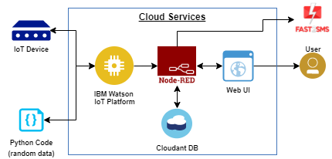

1.2 PURPOSE

The Internet of things (IOT) is the system of gadgets, vehicles, and home machines that contain hardware, programming, actuators, and networks which enables these things to interface, collaborate and trade information. IOT includes broadening Internet network past standard device, for example, work areas, workstations, cell phones and tablets, to any scope of generally stupid or non-web empowered physical device and ordinary articles

## 2.Literature Survey:

* In the year of 2008, Chen Peijiang and Jiang Xuehhua, “Design and implementation of Remote Monitoring System Based on GSM”, this paper focuses on the wireless monitoring system, because the wireless remote monitoring system has more applications than a remote monitoring system based on SMS through GSM.
* “Internet of Things (IOT) based Gas Leakage Monitoring and Alerting System with MQ-2 Sensor” in the year of 2017, Rohan Chandra Pandey, Manish Verma, Lumesh Kumar Sahu. This paper's choice of using a real time gas leakage monitoring and Sensing the outputs levels of gas has been clearly observed by the help of this system.
* “Gas Leakage Detection and Smart Alerting System Using IoT '' in the year of 2018, Shital Image, Priyanka Rajmanes, Aishwarya Gavali. In this paper we use IOT technology for enhancing the existing safety standards. While making this prototype has been to bring a revolution in the safety against the leakage of harmful and toxic gases.

## 2.1 Existing Problem:

The design of a sensor-based automatic gas leakage detector with an alert and control system has been proposed.This is an affordable, less power using, lightweight, portable, safe, user friendly, efficient, multi featured and simple system device for detecting gas. Gas leakage detection will not only provide us with significance in the health department but it will also lead to raise our economy, because when gas leaks it not only contaminates the atmosphere, but also wastage of gases will hurt our economy. The need for ensuring safety in workplaces is expected to be the key driving force for the market over the coming years.

## 2.2 Reference:

* 2013.Arun Raj, Athira Viswanathan, Athul T S, “LPG Gas Monitoring System”, International Journal of Innovative Technology and Research, Volume 3, Issue 2, February 2015, Pg – 1957 to 1960.
* S Shyamaladevi, V. G. Rajaramya, P. Rajasekar, P. Sebastin Ashok, “ARM7 based automated high-performance system for LPG refill booking & leakage detection”, Journal of VLSI Design and Signal Processing”, Volume 3, Issue 2, 2014.
* S. Sharma, V. N. Mishra, R. Dwivedi, R. Das, “Classification of gases/odours using Dynamic Response of Thick Film Gas Sensor Array”, IEEE Conference on Sensors Journal, 2013.
* Ankit Sood, Babalu Sonkar, Atul Ranjan, Mr. Ameer Faisal, “Microcontroller Based LPG Gas Leakage Detector Using GSM Module”, International Journal of Electrical and Electronics Research, Volume 3, Issue2, AprilJune 2015.
* Rajeev B. Ahuja, Jayant K. Dash, Prabhat Shrivastava, “A comparative analysis of liquefied petroleum gas (LPG) and kerosene related burns”, Burns, Volume 37, Issue 8, December 2011.
* Shivalingesh B. M, Ramesh C, Mahesh S. R, Pooja R, Preethi K. Mane, Kumuda S, “LPG Detection, Measurement and Booking System”, IJRSI, Volume 1, Issue 4, November 2014.

## 2.3 Problem Statement:

Gas Leaks from equipment can become dangerous. Conducting routine leak detection inspections to a facility can help prevent unexpected incidents. By Installing gas leakage detection system to prevent these unexpected incidents.

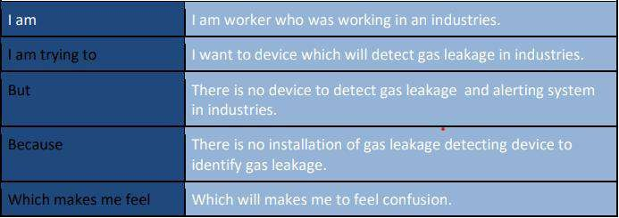

EXAMPLE:

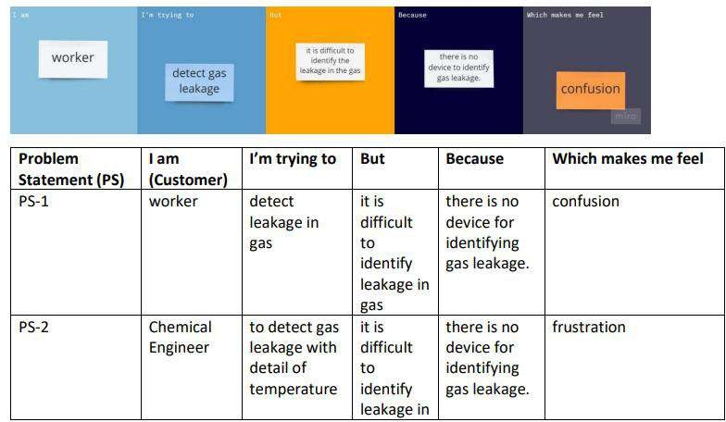

# 3.Ideation and Proposed solution:

## 3.1Empathy map canvas:

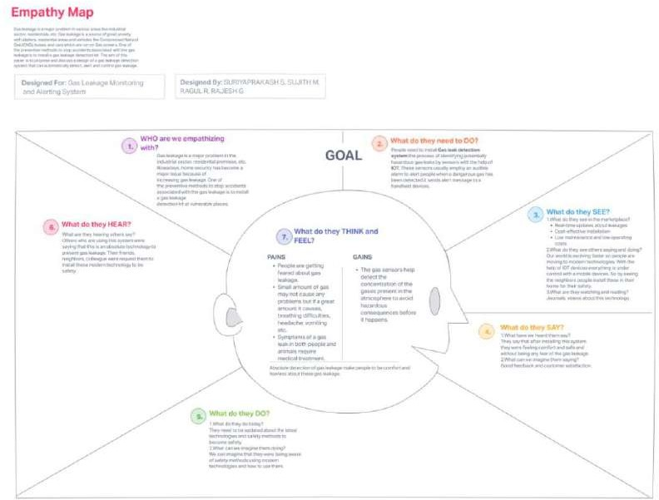

**3.2 Ideation and Brainstorming:**

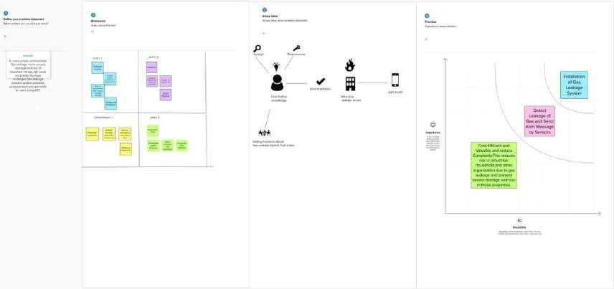

## 3.3 Proposed Solution:

|  |  |  |
| --- | --- | --- |
| **S.no** | **Parameter** | **Description** |
| **1.** | Problem Statement (Problem to be solved) | Gas Leaks from equipment can become dangerous. Conducting routine leak detection inspections to a facility can help prevent unexpected incidents. By Installing gas leakage detection system to prevent  these unexpected incidents. |
| **2.** | Idea / Solution description | The gas leakage detectors can be used for the detection of combustible, flammable and poisonous gaseous, and also to detect a gas leak or other pollutants. It makes the area where the leak occurs an warning sound and instructs operators to leave the area. The System proposed is planned, built and sent an SMS warning system for detection of gas leakage. Infrared imaging sensors have recently been used for a number of applications in industrial plants  and refineries. |
| **3.** | Novelty / Uniqueness | It will detect gas leakage with help of Internet of Things technology and alert the customer using an alerting  device. |
| **4.** | Social Impact / Customer Satisfaction | 1.spending power, 2.Budget,  3.Network connection, 4.available devices,  5.Gadgets to monitor leakage. |
| **5.** | Business Model (Revenue  Model) | By using this model, we can  detect gas leakage and it will |

|  |  |  |
| --- | --- | --- |
|  |  | alert the user when gas leakage  occurs. |
| **6.** | Scalability of the Solution | As this model depends on Internet of Things, It will works on through the Internet and send SMS to mobile if gas leakage happen in user  residential area |

**3.4 Problem Solution fit:**

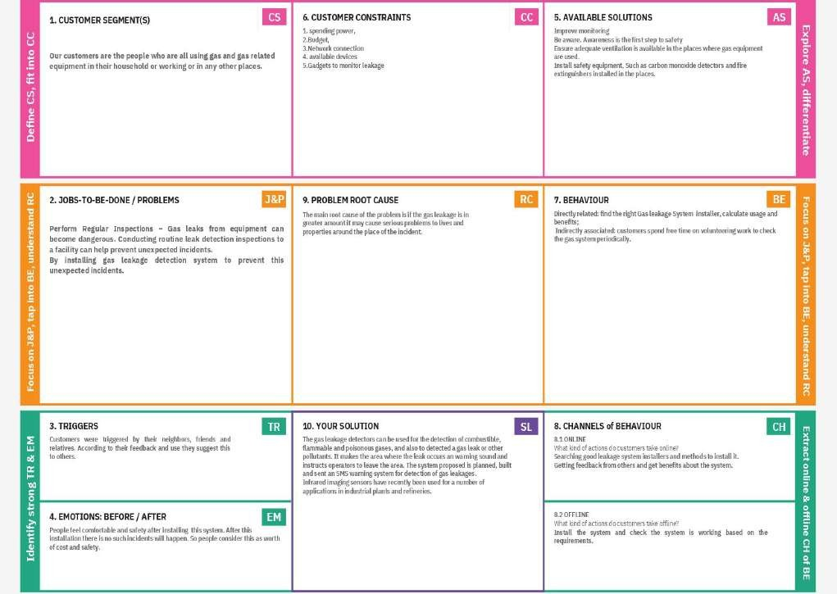

# 4.Requirement Analysis:

## 4.1 Functional Requirement:

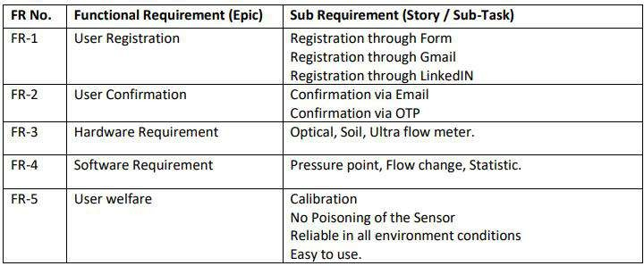

**4.2 Non Functional Requirement:**

|  |  |  |
| --- | --- | --- |
| **FR No.** | **Non-Functional Requirement** | **Description** |
| NFR-1 | **Usability** | The sensor-enabled solution helps prevent the high risk of gas explosions and affecting any casualties within and outside the premises |
| NFR-2 | **Security** | The device is intended for use in household safety where appliances and heaters that use natural gas and liquid petroleum gas (LPG)  may be a source of risk. |
| NFR-3 | **Reliability** | Gas Leakage Detection System (GLDS) can detect leakage at homes, commercial premises or factories. GLDS detects the leakage soon after it happened and sends users an immediate alarm on the incident. |
| NFR-4 | **Performance** | The Gas Leakage Detector is a wall mounted device fitted close to the floor level with an alarm setting at 20% of lower explosive limit. Whenever there is a leak, the in-built sensor detects and alerts the user in less than 5 minutes, much before it can cause any accidents. |
| NFR-5 | **Availability** | The circuit for an LPG leakage detector is  readily available in the market, but it is |

|  |  |  |
| --- | --- | --- |
|  |  | extremely expensive). Presented here is a low -cost circuit for a Gas Leakage Detection that you can build easily. |
| NFR-6 | **Scalability** | The system proves the need for gas detection alarm systems to be 100% reliable. A backup power supply can be included in the system design to augment for power failure condition. Also, calibration of the gas sensor can be done in other for a specific gas to be sensed instead of the LPG numerous  gases it sens e |

# 5.Project Design:

## 5.1Data flow Diagram:

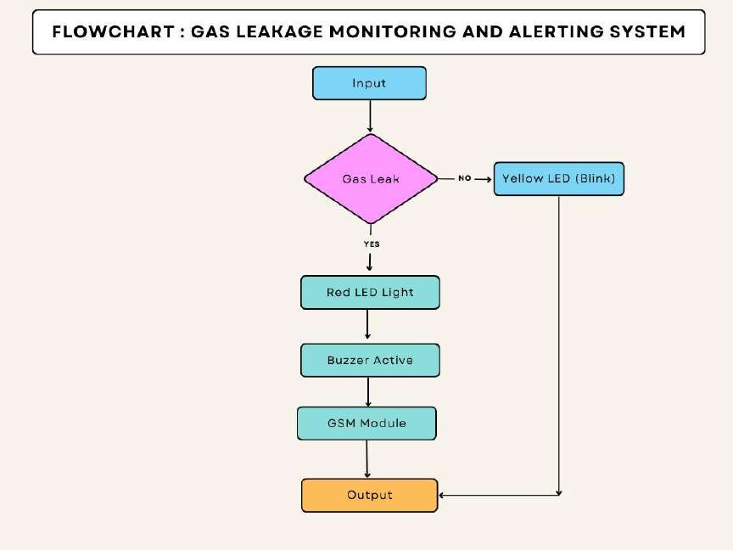

**5.2 SOLUTION & Techincal Architecture:**

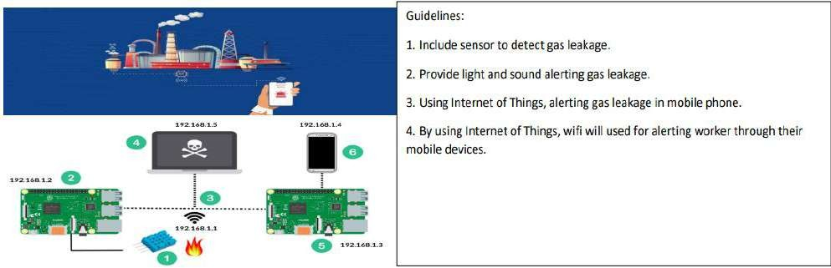

## 5.3 User Stories:

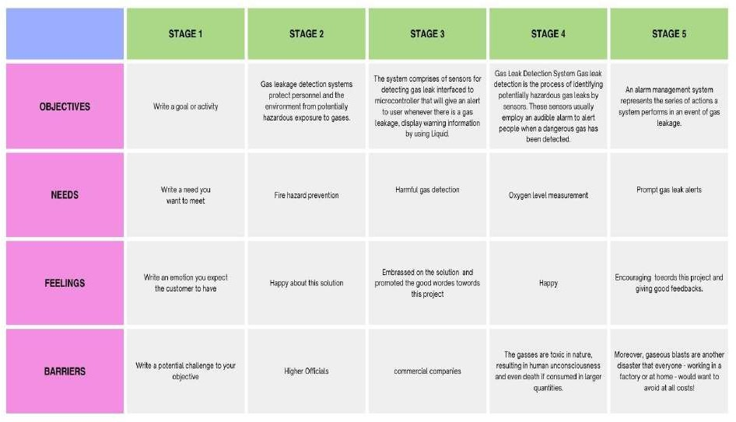

**6.Project planning and Scheduling:**

6.1 SPRINT DELIVERY AND SCHEDULING:



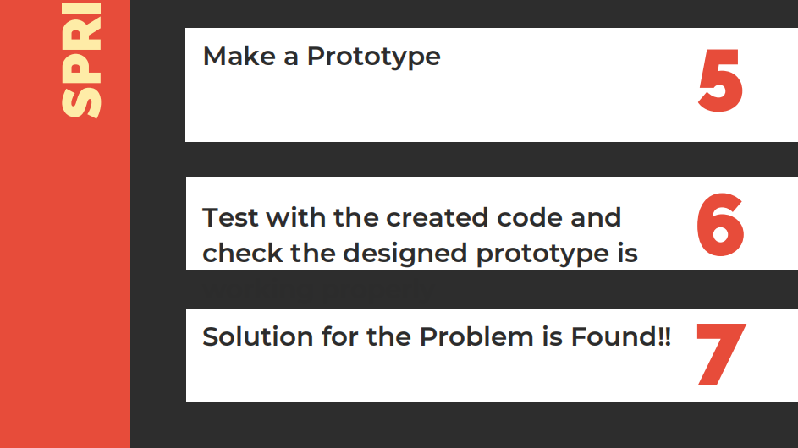

## 7.Coding and Solution:

7.1 FEATURE 1

#include <LiquidCrystal.h> LiquidCrystal lcd(6, 7, 8, 9, 10, 11); float gasPin = A0;

float gasLevel; int ledPin = 2;

int buttonPin = 3; int buzzPin = 4; int buttonState; int fan = 5;

void setup(){ pinMode(ledPin, OUTPUT); pinMode(buttonPin, INPUT);

pinMode(gasPin,INPUT); pinMode(fan,OUTPUT); Serial.begin(9600); lcd.begin(16, 2); lcd.setCursor(0,0); lcd.print(" Welcome"); lcd.setCursor(0,2);

lcd.print("PNT2022TMID33446");

delay(500); lcd.clear();

}

void loop(){

// Read the value from gas sensor and button gasLevel = analogRead(gasPin);

buttonState = digitalRead(buttonPin);

// call the function for gas detection and button work gasDetected(gasLevel);

buzzer(gasLevel); exhaustFanOn(buttonState);

}

// Gas Leakage Detection & Automatic Alarm and Fan ON void gasDetected(float gasLevel){

if(gasLevel >= 200){ digitalWrite(buzzPin,HIGH); digitalWrite(ledPin,HIGH); digitalWrite(fan,HIGH); lcd.setCursor(0,0); lcd.print("GAS:"); lcd.print(gasLevel); lcd.setCursor(0,2); lcd.print("FAN ON"); delay(1000);

lcd.clear();

}else{ digitalWrite(ledPin,LOW); digitalWrite(buzzPin,LOW); digitalWrite(fan,LOW); lcd.setCursor(0,0); lcd.print("GAS:"); lcd.print(gasLevel);

lcd.setCursor(0,2); lcd.print("FAN OFF"); delay(100); lcd.clear();

}

}

//BUZZER

void buzzer(float gasLevel){ if(gasLevel>=200)

{

for(int i=0; i<=30; i=i+10)

{

tone(4,i); delay(300); noTone(4); delay(4300);

}

}

}

// Manually Exhaust FAN ON

void exhaustFanOn(int buttonState){ if(buttonState == HIGH){ digitalWrite(fan,HIGH); lcd.setCursor(0,0); lcd.print("Button State:"); lcd.print(buttonState); lcd.setCursor(0,2);

lcd.print("FAN ON"); delay(10000); lcd.clear();

}

}

## 8.Testing:

**8.1 Test case 1:**

Industries at normal temperature, it is not alerted.

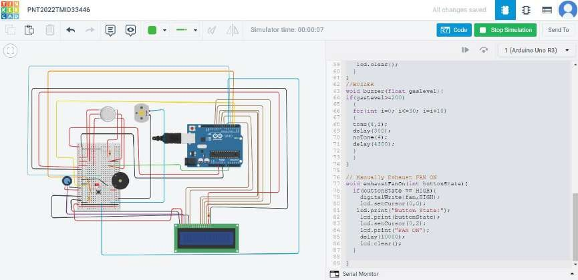

## 8.2 USER ACCEPTANCE TESTING

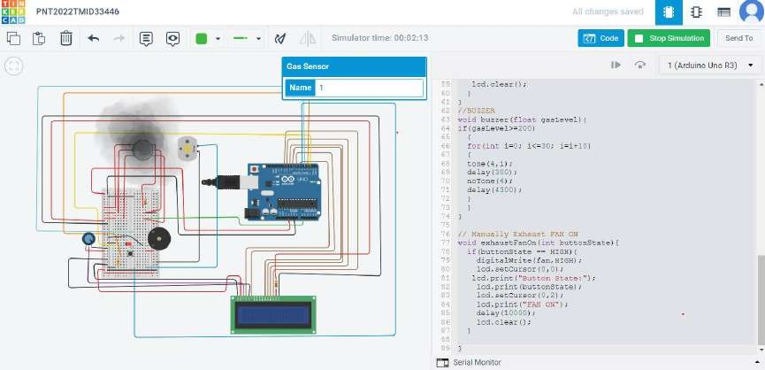

Due to gas leakage in industries, this circuit model is alerting the worker through their mobile phone. It will be monitor and rectify by workers in industries.

1. RESULTS:
   1. PERFORMANCE METRICES:



**10 .Advantage and Disadvantage:**

## Advantage:

* This project helpful for detecting gas leakage in Industries.
* Component and Equipment are more efficient.
* Lower power consumption and reliable.
* It is also used in house for LPG gas leakage.

## Disadvantage:

* Location cannot be identify where gas leaking because there are several areas contain gas cylinder.
* It is sensitivity depends on Humidity and Temperature.
* Without Internet, This will not run and work.
* Installation is difficult.

# 11.Conclusion:

After this project performance, can conclude that detection of the LPG gas leakage is incredible in the project system. Applicable usefully in the industrial and domestic purpose. In danger situations we are able to save the life by using this system. An alert is indicated by the GSM module. A sensor node senses gas like CO2, oxygen, propane. The estimated range of transmission and consumption of power is obtained. The simple procedures and Arduino UNO Micro controller area used to build the sensor.

12.FUTURE SACOPE:

Another major future scope could be including a Automatic Shut-off device which will turn off the gas supply whenever it will detect any gas leakage. This system can be implemented in Industries, Hotels and wherever the LPG cylinders are used.

## 13 .Appendix:

SOURCE CODE:

#include <LiquidCrystal.h> LiquidCrystal lcd(6, 7, 8, 9, 10, 11);

int redled = 2;

int greenled = 3;

int buzzer = 4;

int sensor = A0;

int sensorThresh = 400;

void setup()

{

pinMode(redled, OUTPUT);

pinMode(greenled,OUTPUT);

pinMode(buzzer,OUTPUT);

pinMode(sensor,INPUT);

Serial.begin(9600);

lcd.begin(16,2);

}

void loop()

{

int analogValue = analogRead(sensor);

Serial.print(analogValue);

if(analogValue>sensorThresh)

{

digitalWrite(redled,HIGH);

digitalWrite(greenled,LOW);

tone(buzzer,1000,10000);

lcd.clear();

lcd.setCursor(0,1);

lcd.print("ALERT");

delay(1000);

lcd.clear();

lcd.setCursor(0,1);

lcd.print("EVACUATE");

delay(1000);

}

else

{

digitalWrite(greenled,HIGH);

digitalWrite(redled,LOW);

noTone(buzzer);

lcd.clear();

lcd.setCursor(0,0);

lcd.print("SAFE");

delay(1000);

lcd.clear();

lcd.setCursor(0,1);

lcd.print("ALL CLEAR");

delay(1000);

}

**Github Link:**

**https: //github.com/IBM-EPBL/IBM-Project-46916-1660794683**